How to Request Data Entry

Broker or AE/LO To Complete
- Go to Stronghill Portal
  - Add New Loan
    - Wholesale
      - Add Loan Officer and Loan Processor Names
    - Click on Manual > Next
  - Enter the following fields (Click Register and the fields to Enter will be visible in a box)
    - Borrower First and Last Name
    - Loan Purpose (Purchase, Cash-Out, Rate and Term)
    - Credit Report By (Stronghill or Broker) **Only available if requested on Company application
      - Broker Credit Report = must re-issue report in TPOC upfront
    - Income Documentation Type
    - Purpose of Loan
    - Impounds or Waived
    - Subject Property City
    - Subject Property State
    - Subject Property Zip
    - Application – Data Entry Requested = Yes
  - Click Save>Register
- Go to Loan Documents tab
  - Under Loan Submission Docs
    - Upload a Complete Application
    - Upload Credit Authorization – if Stronghill will pull credit report
- Broker will receive email notification of request received by Stronghill
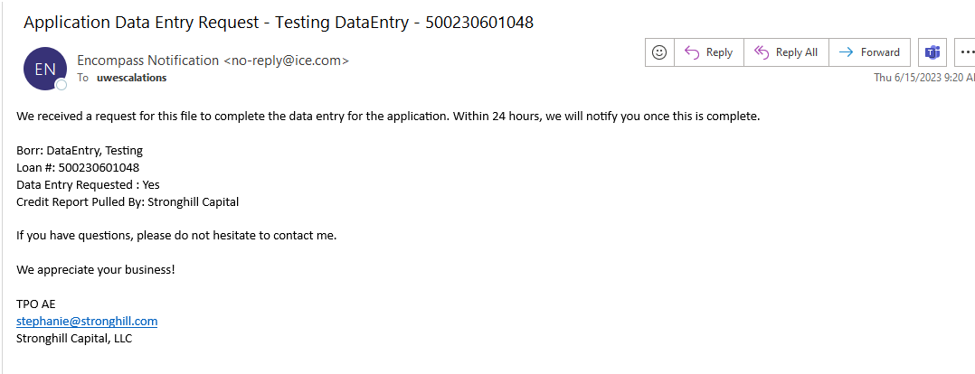

Review Complete
Once the review is complete, go to the Stronghill portal,
- Complete product and pricing
- Upload any supporting documentation for underwriting to review
- Loan Action = UW- Submit/Resubmit (click once ready for UW review)
**If the application was incomplete, upon submitting to Underwriting, the system will prompt you to enter the information.
Sample notification email once data entry or credit report complete: